Azure Assignmnet

Task 1: Create a virtual network with 2 subnets. Each subnet should have 16 Ips only.

Virtual network with 2 subnets and each have 16 ips.

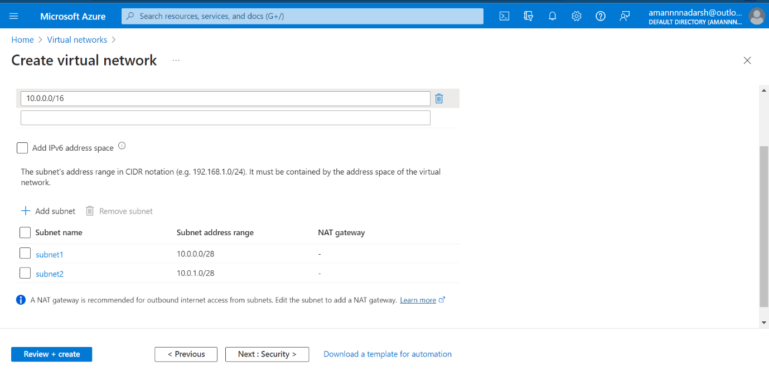

Virtual network creation validation passed.

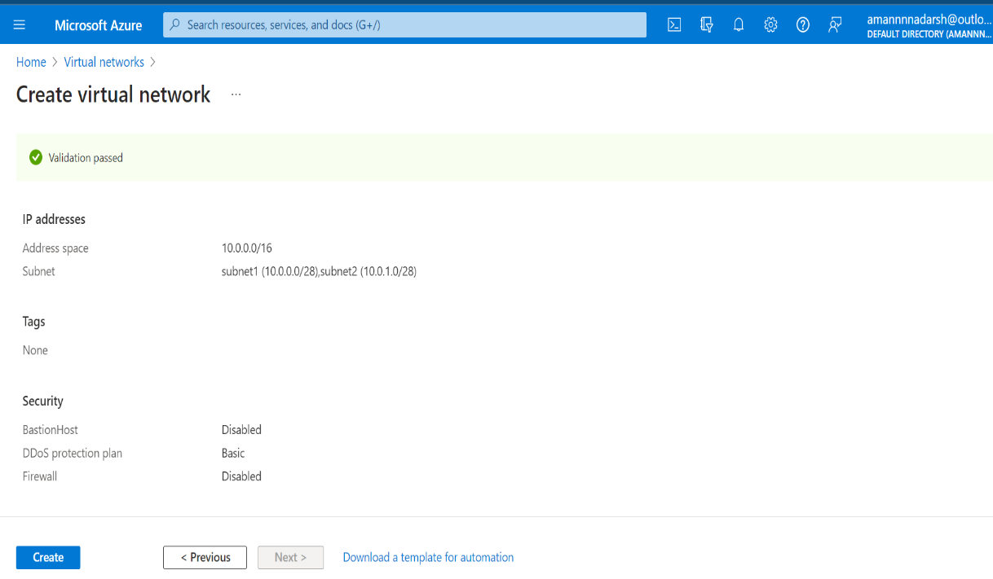

Virtual network finally created.

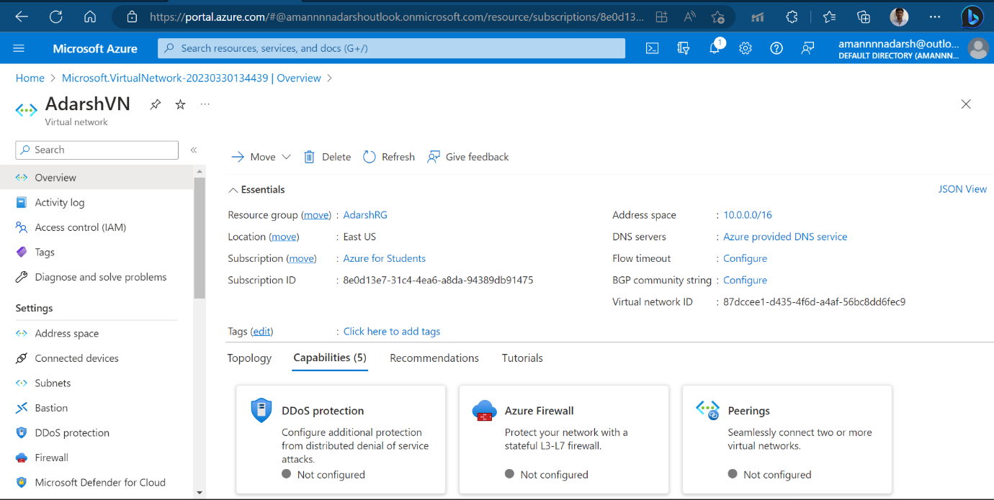

Task 2: Inside one of the subnets, create a VM and deploy an application code inside it and it should leverage the database on the cloud (any existing application created by you before)

Virtual machine creation validation passed.

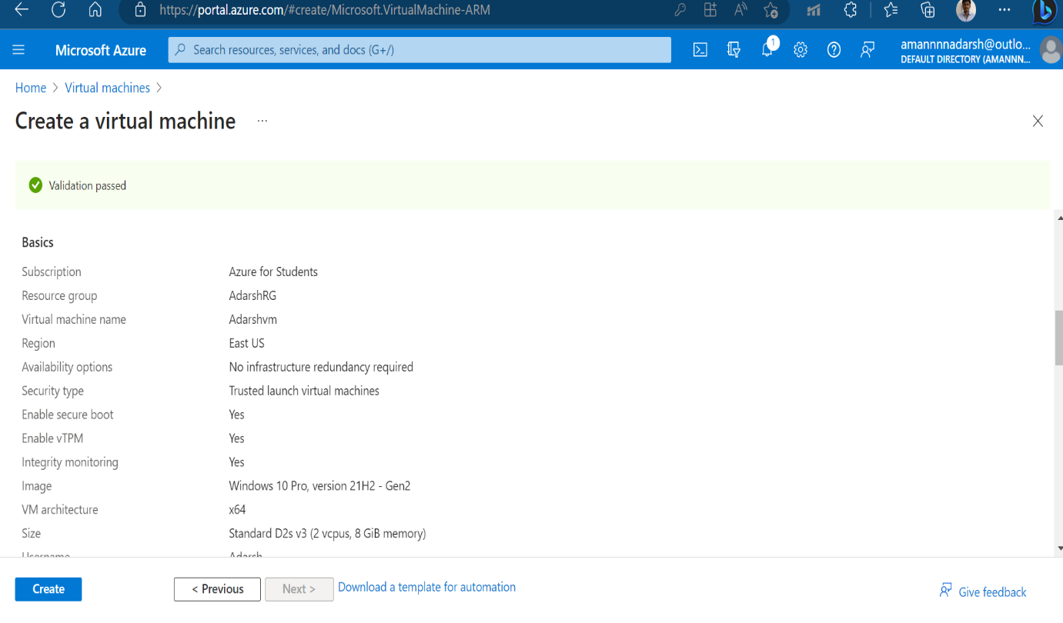

Virtual machine is inside subnet1 that is created before.

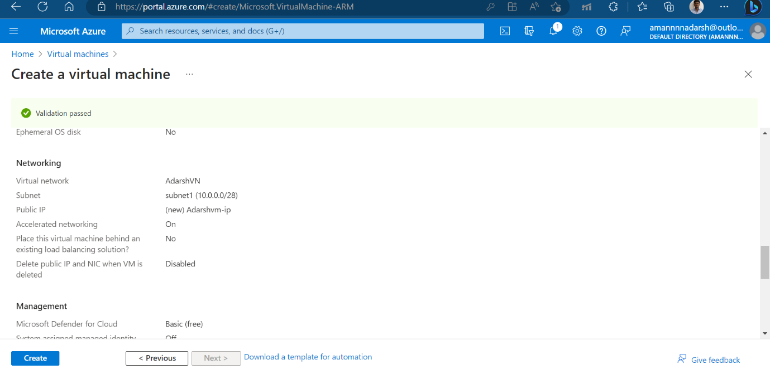

Virtual machine created, up and running with public ip address – 20.169.247.185.

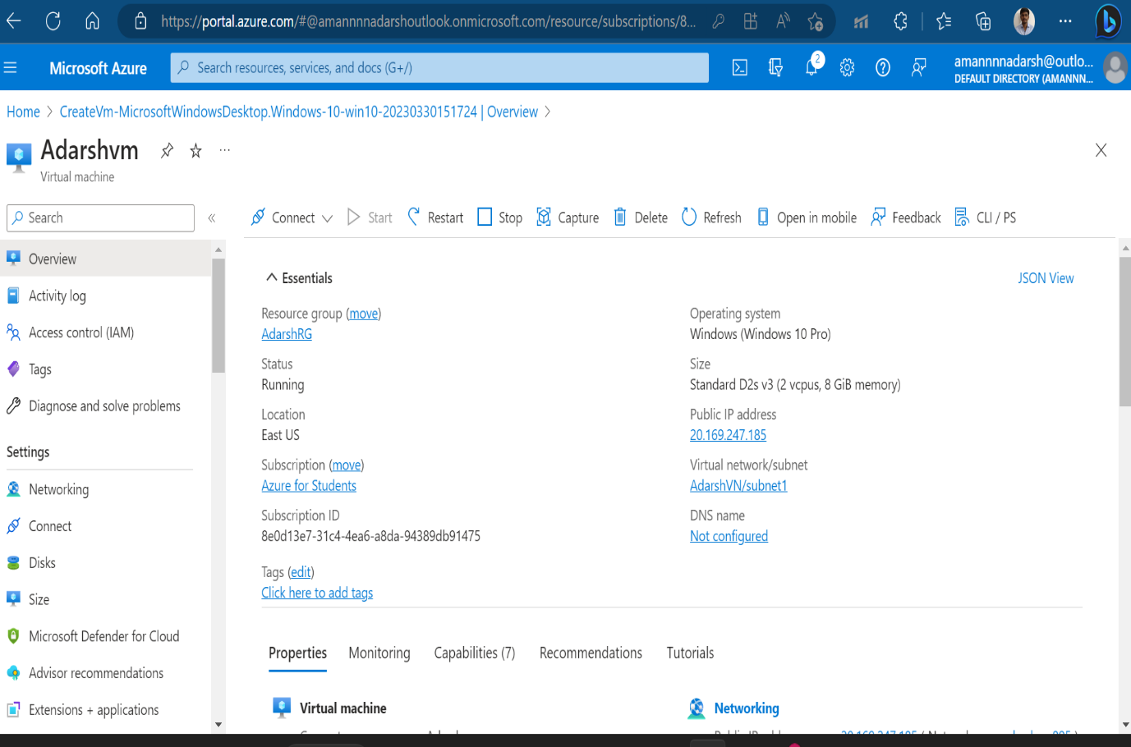

Azure MySQL database creation for application having database on cloud.

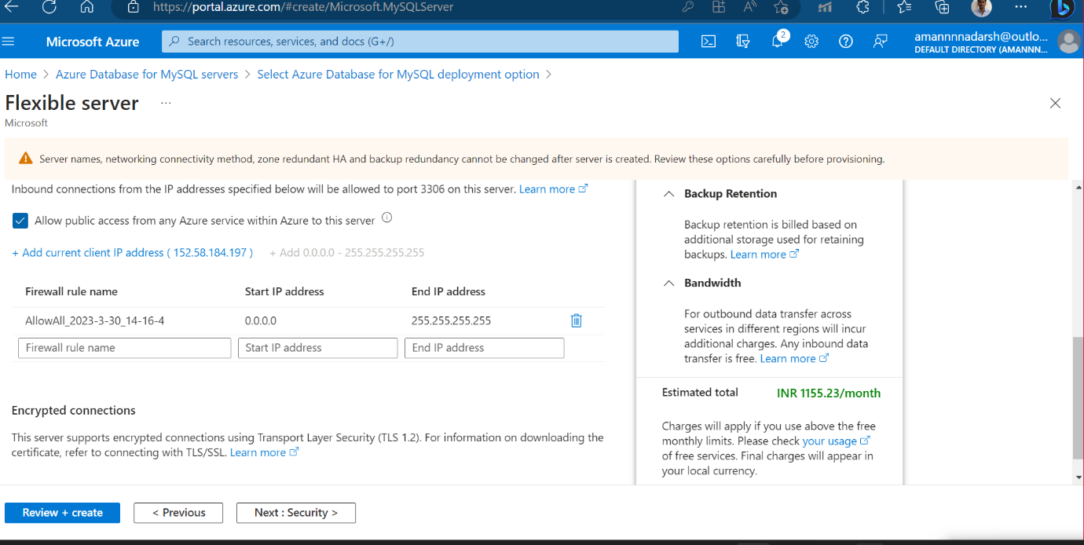

Azure MySQL database creation is under process.

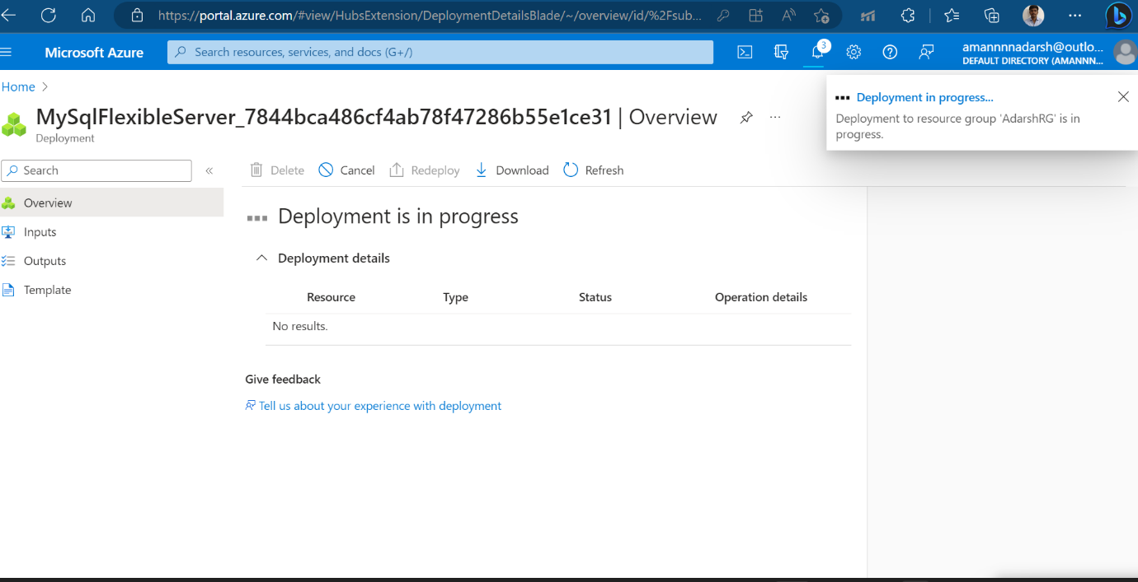

Azure MySQL database creation complete and up and running.

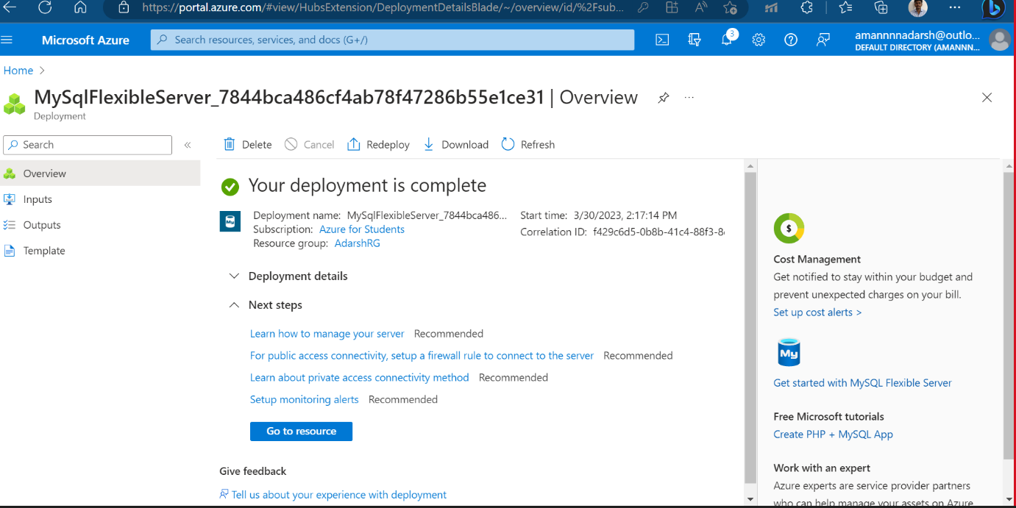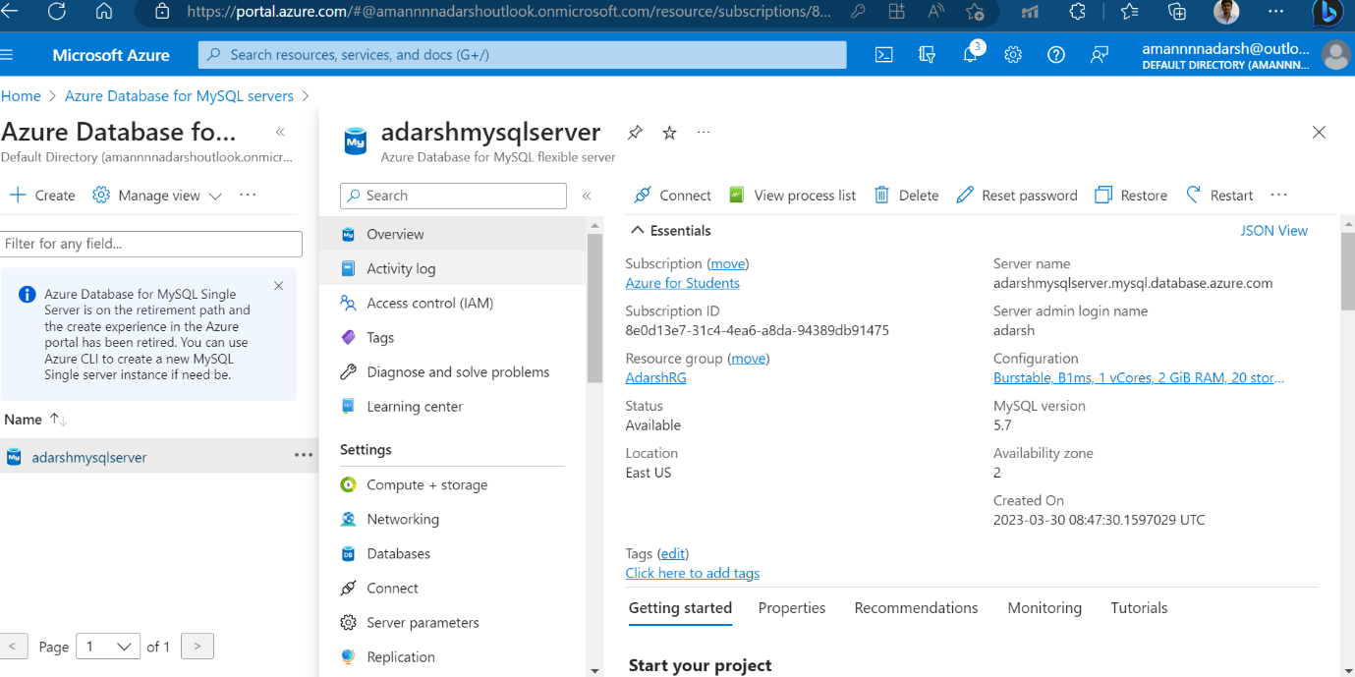

Azure mysql database connected to mysql workbench.

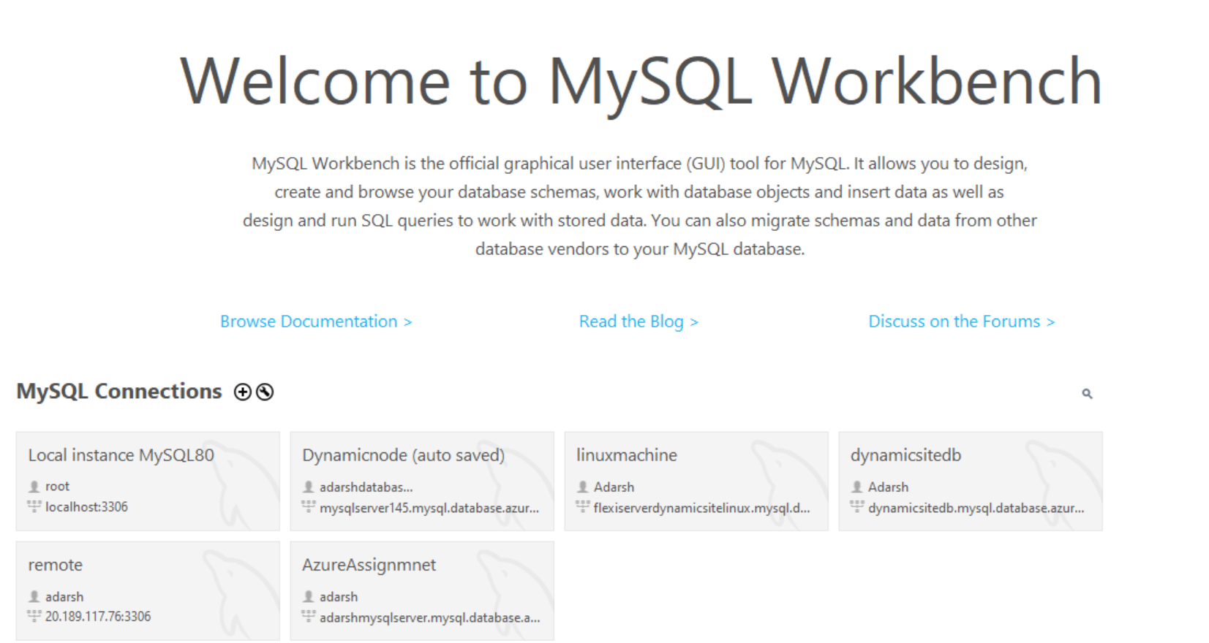

In that we created a database with name “adarshmysql”.

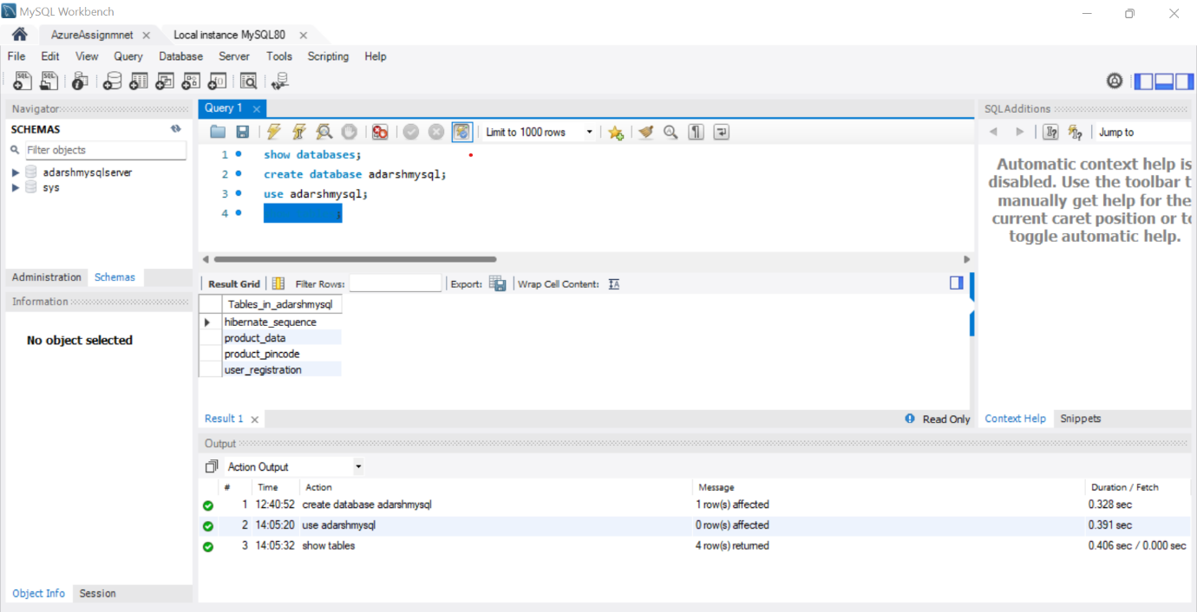

Application deployed in Virtual machine, up and running.

And accessible through public ip address of VM.

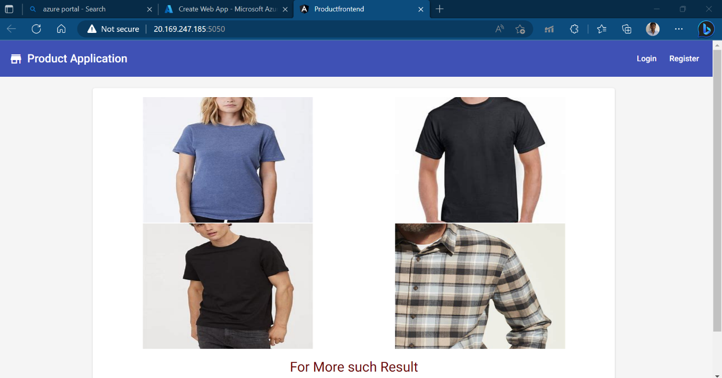

Task 3: Deploy the same application to Azure App Service. It should also leverage the database on the cloud.

App service creation and deployment is under process.

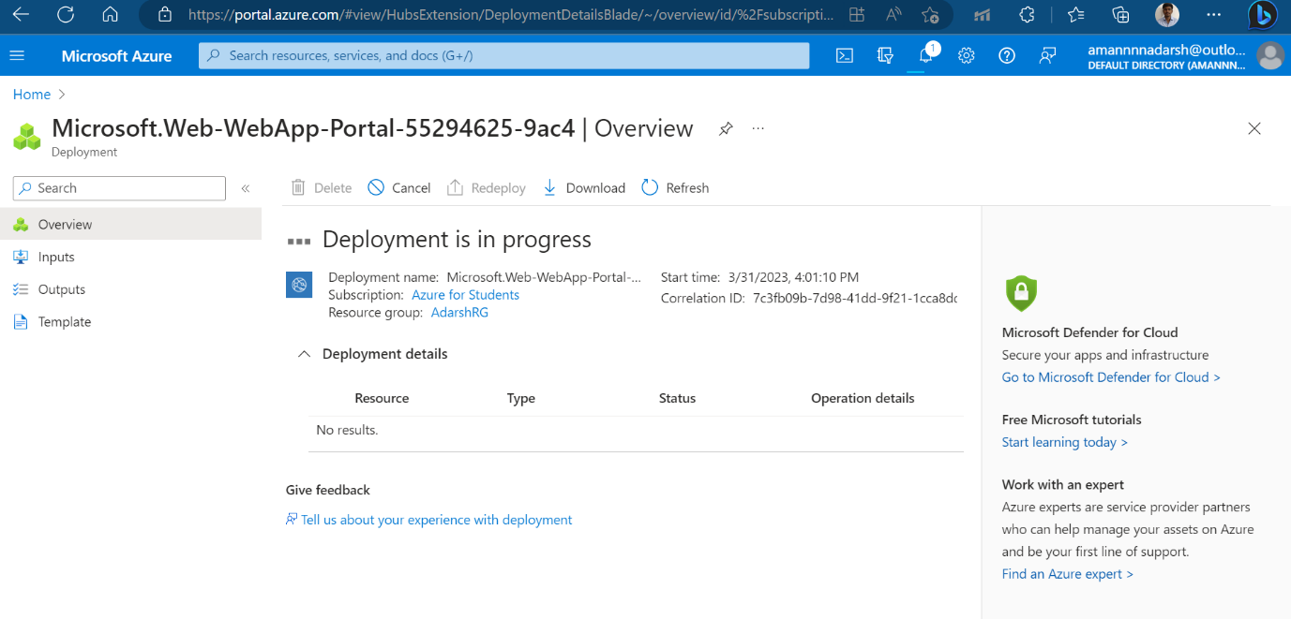

App service created successfully, up, and running.

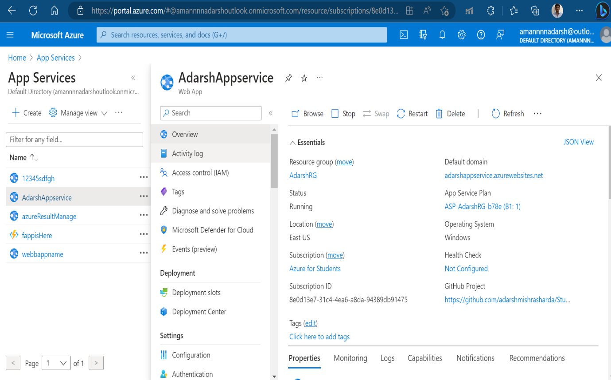

Build and deployed application on GitHub to app service deployment is successful.

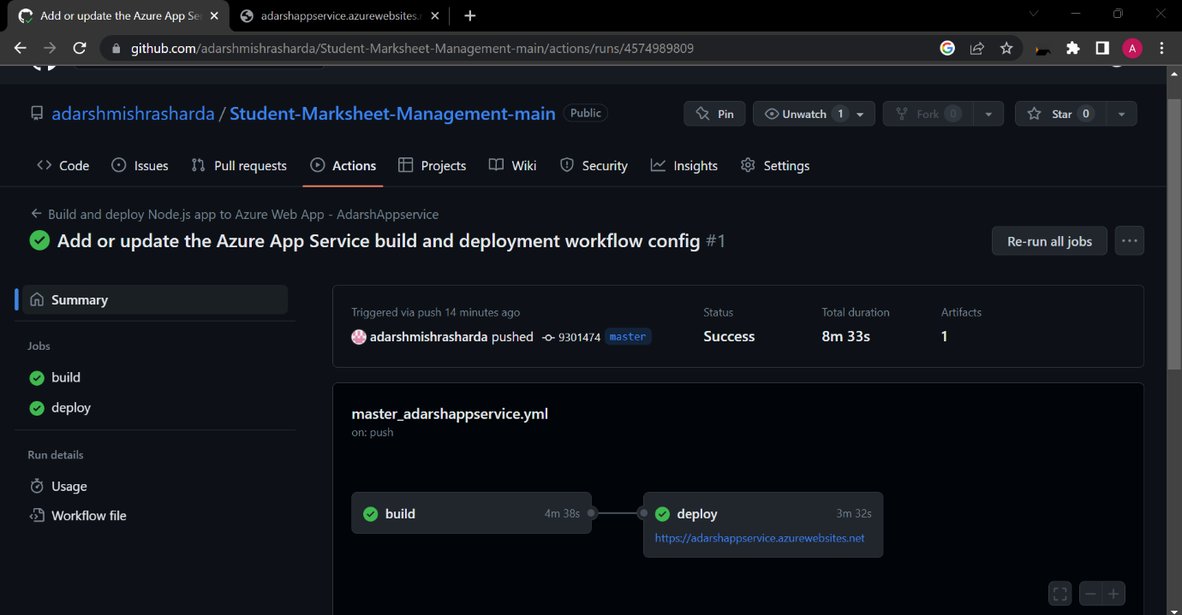

App Service Deployment centre Screen shot

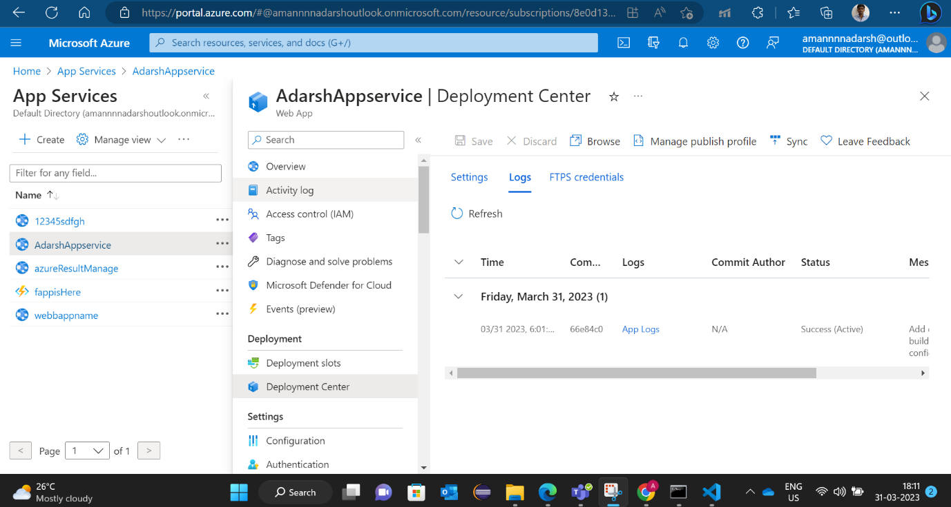

Deployed web app on App service is running successfully and accessible with app service default domain link.

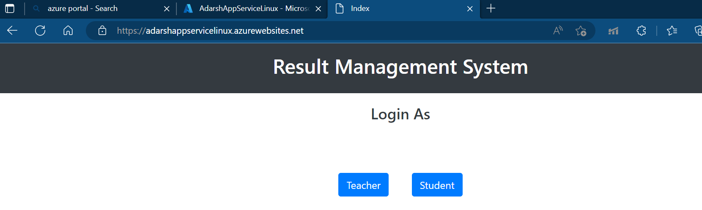

Task 4: Create the AKS cluster (2 nodes, smallest size VM) and deploy any two services on it. Services should be accessible from the internet.

Task 5. Create an Azure function that should trigger as soon as you upload a file in the blob storage. Function should be able to print the name of the file uploaded in the function.

Function App creation is successful and up and running.

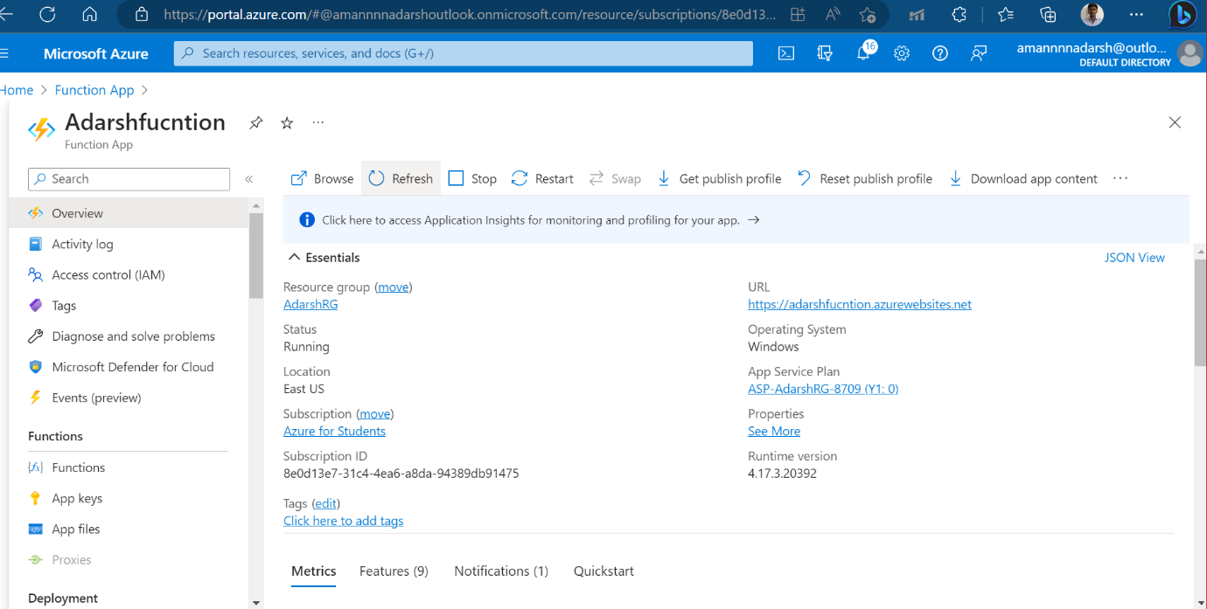

Storage Account created successfully.

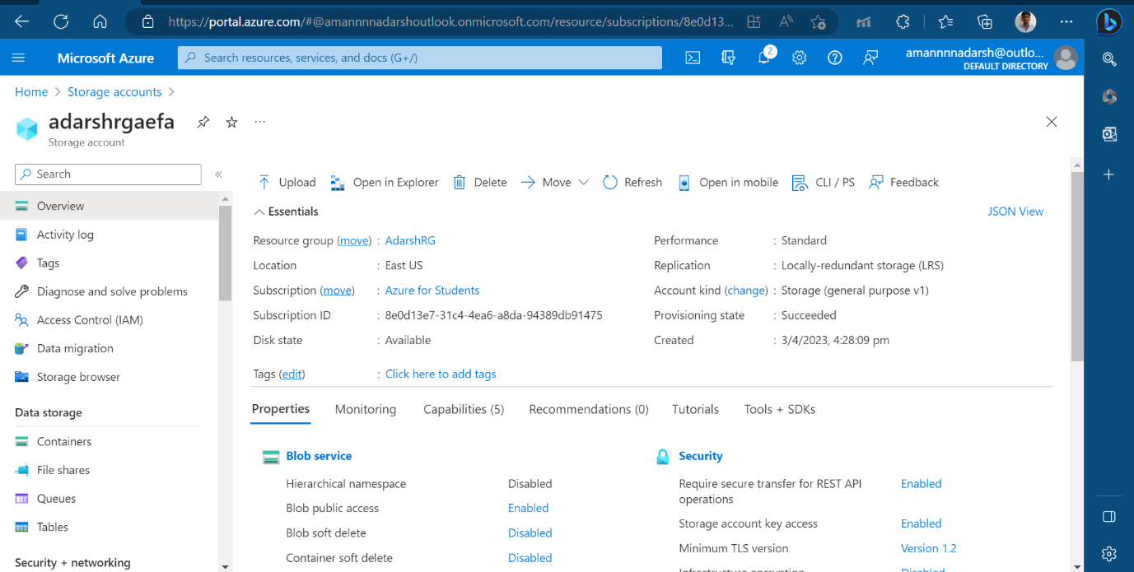

Container is created.

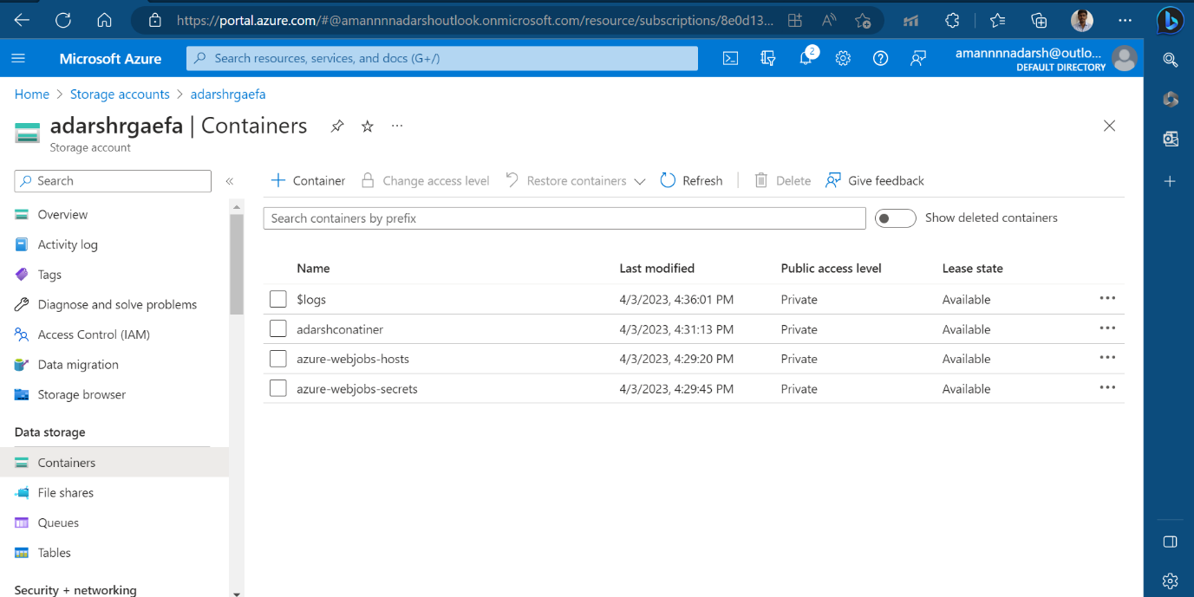

Inside container a file get uploaded successfully. Now further we see trigger in function app that shows file name and size.

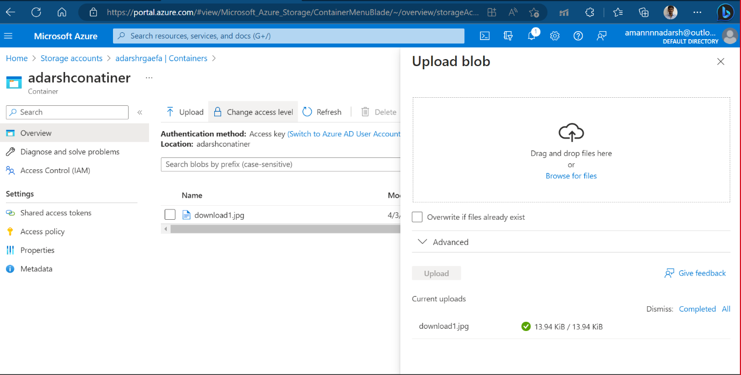

Here in function app monitoring section showing file uploaded successfully.

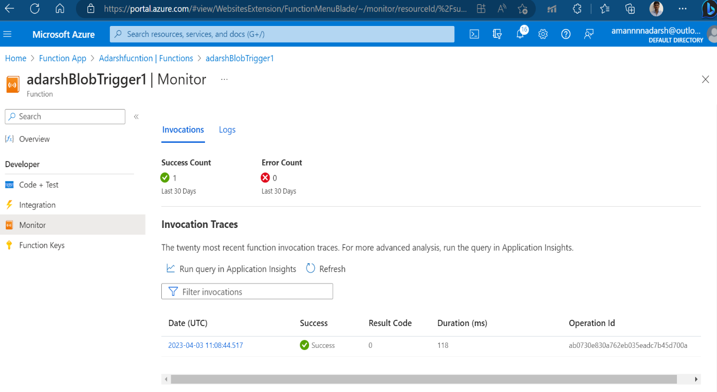

Here in function app monitoring section logs showing file uploaded successfully showing file name and size .

